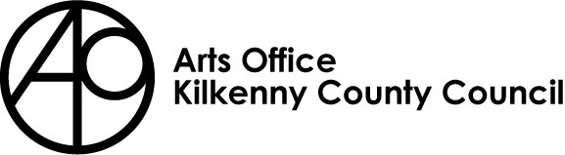
Arts Office, Kilkenny County Council
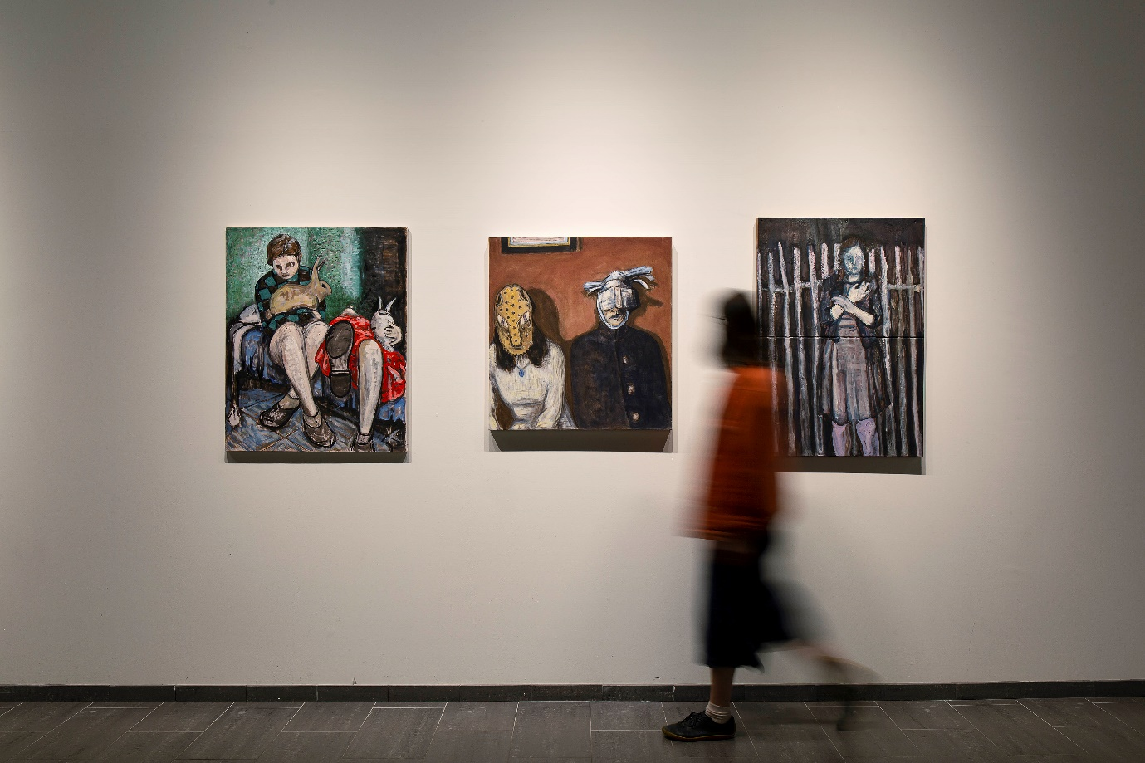
Artist Lee Shanahan / Curator Sinead Keogh 2022

EMERGING CURATOR DEVELOPMENT PROGRAMME

Kilkenny County Council Arts Office invites applications from Emerging Curators for their 2023 Emerging Curator Development Programme (ECDP). The Arts Office initiated this programme in 2019, to support emerging curators in developing and progressing their skills, experience and ultimately their careers.

The successful applicant will
- gain experience and professional development in curating and managing exhibitions / projects
- develop and expand their networks and relationships across the arts and culture sector
- participate in the artistic programming of the city and county of Kilkenny showcasing the works of contemporary artists
- further enhance the arts and cultural offer in Kilkenny to local and national audiences alike
- benefit from working alongside a long-established Arts Department within Kilkenny County Council, benefitting from the years of experience and expertise of the Arts Officer and her staff
- be mentored by Etaoin Holahan, a curator living and working in Callan, Co. Kilkenny with over ten years of experience in curating, producing and presenting multi-disciplinary projects focused on community & civic engagement.

RESPONSIBILITIES OF THE CURATOR –
- Curate and deliver up to three exhibitions / projects across an agreed period of time
- Manage the budget and provide regular updates to the Arts Officer
- Manage the artists in regards to Local Authority set up and invoicing
- Work with the Arts Office and their mentor to realise these exhibitions / projects
- Research and engage the artists to be a part of the exhibitions/ projects and be responsible for the logistics for each
- Produce press material and social media content for each exhibition/project in a timely manner
- Manage the Arts Office Instagram account for the duration of the programme
- Write and upload regular blog updates, see http://kilkennyartsoffice.ie/
- Work with the artists to write the all texts for the exhibitions / projects when relevant
- Work closely with the Arts Office to manage all aspects of the exhibitions / projects working within the constraints of the space(s) they work in
- The exhibitions / projects must impact and benefit artists and /or communities in Kilkenny
  - This can include communities of place, historical /environmental/social aspects of Kilkenny or a specific demographic.
  - Projects may also include an international context and / or feature new ways of working reflecting the current global pandemic.
  - All projects can feature a solo practitioner and
  - One exhibition / project must feature an emerging Kilkenny artist at its core
- The programme must include a minimum of one audience development / engagement initiative per exhibition / project. The Emerging Curator will utilise the existing networks and contacts of the Arts Office to support the realisation of these associated events, they will also endeavour to forge new relationships.
- The curator must be cognisant of working inclusively when organising such initiatives, taking local groups, new communities, young people and diversity into consideration
- Provide a final report and complete the Arts Office’s ‘pre’ and ‘post’ programme evaluation forms.
- Meet all project deadlines provided by the Arts Office and any media outlets.

*NB for 2023 the exhibitions / projects will not necessarily be delivered or presented in a traditional gallery space, but instead may be curated for alternative sites and spaces where possible. This can also include online space and sites county wide where available.

The successful candidate will receive
- A curatorial fee of €7,000
- Exhibition / project budget
- Curatorial support, including mentoring
- Technical and installation advice and support
- Logistical support

Description | Emerging curator
Overall period | March – October / November 2023
Exhibition / project proposed timeline | - June/ July –  - July / August this period will include the Annual Kilkenny Arts Festival  - August / September this period will include Culture Night  There is some flexibility within this time line
Brief project details | *All three projects must impact and benefit artists and /or communities in Kilkenny  *This can include communities of place, historical /environmental/social aspects of Kilkenny or a specific demographic.  *Projects may also include an international context and / or feature new ways of working reflecting the current global pandemic.  *All projects can feature a solo practitioner and  *One project must feature an emerging Kilkenny artist at its core  *The curator must be cognisant of working inclusively when organising such initiatives, taking local groups, new communities, young people and diversity into consideration.
Working hours and administration location | Contracted duration – March – November 2023  The successful applicant must commit to working remotely. A minimum of one - two days per week will be expected to be spent on project development and delivery.  The successful candidate can expect the time spent on the projects to increase as they materialise. This will be discussed further and approved with the successful candidate  The first phase will entail networking, research and meeting with relevant personnel to enable and enhance the curator’s successful integration with the arts, culture and creative communities in Kilkenny (depending on restrictions this may be virtual)
Key relationships | Kilkenny County Council Arts Officer: Mary Butler  Mentor: Etaoin Holohan
Curator fee | Curators fee incl. €7,000  There is a separate budget for the exhibitions /projects. Full breakdown will be provided to the successful candidate  The curator in residence will work on a freelance basis and will invoice Kilkenny County Council in three stages, dates tbc
Other | The applicant must outline how their programming will:  - benefit Kilkenny artists  - benefit Kilkenny and its creative sector and wider community  - engage with and build audiences, locally, nationally and potentially internationally  - stimulate and challenge audiences  - include an international context and / or  - feature new ways of working reflecting the current global pandemic.  - How the opportunity would benefit their own career

Who we are looking for / Personal specification - For 2023 this opportunity is opened to emerging curators, artists and project managers

The successful applicant should have:
- a degree in fine art or an associated field
- Knowledge and experience of contemporary visual arts in Ireland and beyond
- Existing artist’s networks OR knowledge of emerging visual artists across the county, the island of Ireland and beyond
- An understanding of the issues facing visual artists in developing their practice
- demonstrable curatorial experience (albeit limited experience)
- have proven project management skills (albeit limited experience)
- Proven ability to build relationships with artists, communities and existing and new audiences
- Knowledge of the artistic vitality of Kilkenny

How to apply:
- Maximum 500-word statement / letter of interest outlining your curatorial rationale / approach and how your programming will
  - benefit Kilkenny artists
  - benefit Kilkenny and its creative sector and wider community
  - engage with and build audiences
- 250 words statement outlining
  - how the opportunity would benefit their own career path as an emerging curator
- Up to date CV Max two pages, please include details / images of previously curated project and / or exhibitions
- Two professional referees

- Applications will be accepted by email in PDF format only
- The file must not exceed 10MB
- Please send completed application to: deirdre.southey@kilkennycoco.ie
- You will receive an acknowledgement of receipt for your application. If you do not receive this e mail within 24 hours of the deadline, please contact the Arts Office on 056 779 4547

Taxation - The successful applicant will be responsible for all taxes, which arise from payment of the agreed fee, including and without prejudice to the generality of this provision all income tax and all VAT.
APPLICATION DEADLINE: TUESDAY 31st January 2023 @ 4pm

FOR FURTHER DETAILS PLEASE CONTACT: Deirdre.southey@kilkennycoco.ie

